II

INTRODUCTION

Handwritten digit recognition has been an active research domain within pattern recognition and machine learning for several decades. With the increasing integration of digital systems in everyday processes such as banking, education, authentication, and document analysis, the ability for machines to accurately interpret handwritten input has become essential. Traditional machine learning techniques relied heavily on handcrafted feature extraction, which limited performance in complex writing styles.
The advancement of deep learning, especially Convolutional Neural Networks (CNNs), has revolutionized the field by enabling systems to learn hierarchical patterns directly from image data. EMNIST (Extended MNIST) provides a modern benchmark for handwritten digit classification, offering a large and diverse dataset that represents natural handwriting variations. Using CNNs on EMNIST significantly improves recognition accuracy and robustness.
This project focuses on building a handwritten digit recognition system using CNN models trained on the EMNIST Digits dataset and integrating the model into a user-interactive Tkinter desktop application.

Despite the availability of digital input devices, many users still write digits manually. Machines often struggle to recognize handwritten digits due to variations in writing styles, stroke thickness, and noise. The challenge is to develop a deep learning model that can accurately classify digits from 0–9 drawn in shapes,sizes,orientations.

CHAPTER 2

OBJECTIVES

The primary objectives of this project are:
- To study and analyze the EMNIST Digits dataset.
- To develop a deep learning architecture using Convolutional Neural Networks (CNNs).
- To preprocess digit images for optimal model accuracy.
- To train and evaluate the handwritten digit classifier.
- To build an interactive GUI application using Tkinter for live digit prediction.
- To analyze the model’s performance using accuracy and loss metrics.
- To develop a scalable pipeline that can be extended to full character recognition in the future.

CHAPTER 3

PROBLEM STATEMENT

To design and implement a CNN-based system capable of accurately identifying handwritten digits using the EMNIST dataset and deploying it in a user-friendly GUI application.

CHAPTER 4

METHODOLOGY

+--------------------+
| EMNIST Dataset |
+---------+----------+
|
v
+--------------------+
| Preprocessing |
| (28x28, normalize) |
+---------+----------+
|
v
+--------------------+
| CNN Model |
| (Conv + Pooling) |
+---------+----------+
|
v
+--------------------+
| Training & |

| Evaluation |

+---------+----------+
|
v
+--------------------+
| GUI (Tkinter) |
| User draws digit |
+---------+----------+
|
v
+--------------------+
| Final Prediction |
+--------------------+

4.1 Block Diagram of Color Prediction System

The methodology adopted in this project follows a structured and systematic approach to develop an efficient handwritten digit recognition system using Convolutional Neural Networks. The entire workflow is divided into several stages, starting from dataset acquisition to model deployment. Each stage ensures that the subsequent processes receive optimized and well-prepared inputs, ultimately improving the performance of the recognition model.

CHAPTER 5

REQUIREMENT ANALYSIS
FUNCTIONAL REQUIREMENTS

1 Data Loading & Preparation
- The system shall load the EMNIST/MNIST digits dataset (or user-supplied digit images).
- The system shall normalize pixel values to the range [0,1] and reshape images to shape (28, 28, 1) prior to training and inference.
- Acceptance: Script train.py successfully loads dataset and prints shapes (e.g., (N,28,28,1)).
2 Preprocessing Pipeline
- The system shall perform preprocessing for GUI captures: convert to grayscale, invert colors if user draws white-on-black, resize to 28×28, and perform any orientation correction required to match training data.
- The system shall optionally crop to the bounding box of the drawn stroke and center it before resizing (configurable).
- Acceptance: main.py produces last_capture_for_model.png that visually matches the expected 28×28 input.
3 Model Architecture and Training
- The system shall implement a Convolutional Neural Network (CNN) with convolution, pooling, and dense layers and output dimension 10 (classes 0–9).
- The system shall train the model using sparse_categorical_crossentropy (or categorical crossentropy if labels one-hot) with Adam optimizer and the configured batch size.
- Acceptance: train.py completes training and saves emnist_model.keras.

NON-FUNCTIONAL REQUIREMENTS

- Performance: Ensure minimal latency during word predictions.
- Accuracy: Maintain high accuracy in predicting contextually relevant words.
- Scalability: Handle large datasets and complex sequences efficient.

CHAPTER 6

FLOW CHART

DESIGN

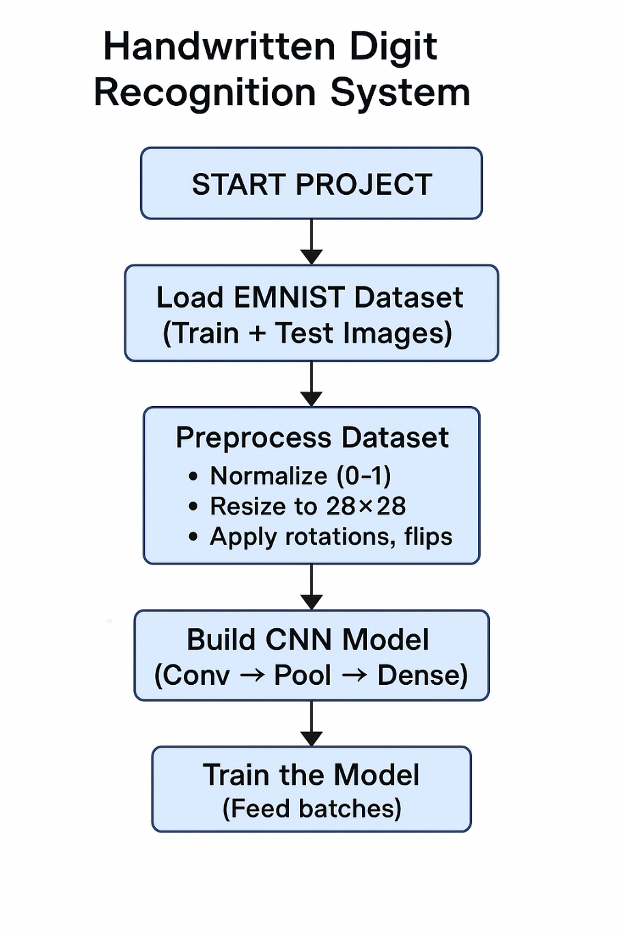 Fig 6.1 Flow Chart

USE CASE DIAGRAM

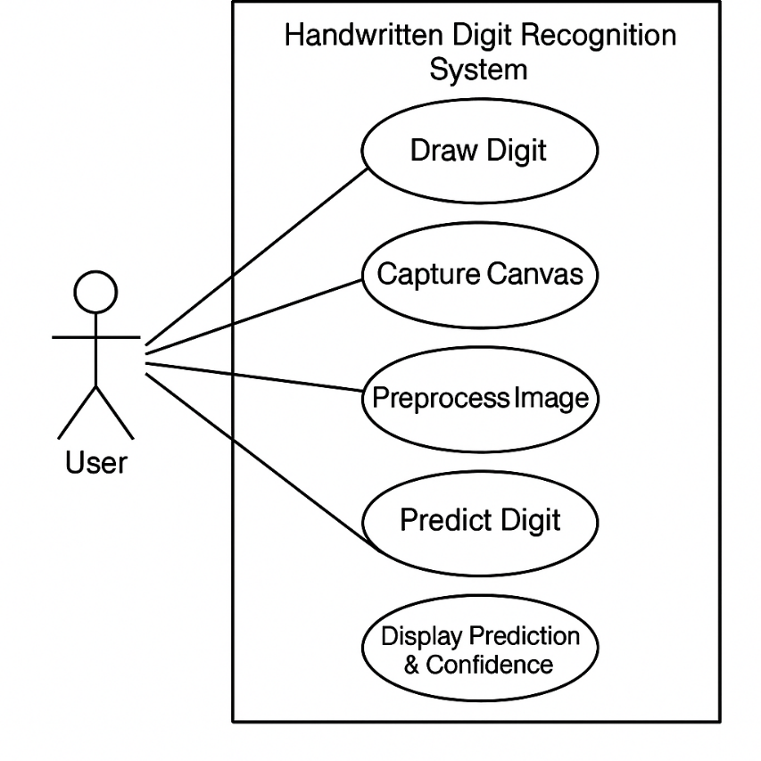

Fig 6.2 Use Case Diagram

SEQUENCE DIAGRAM

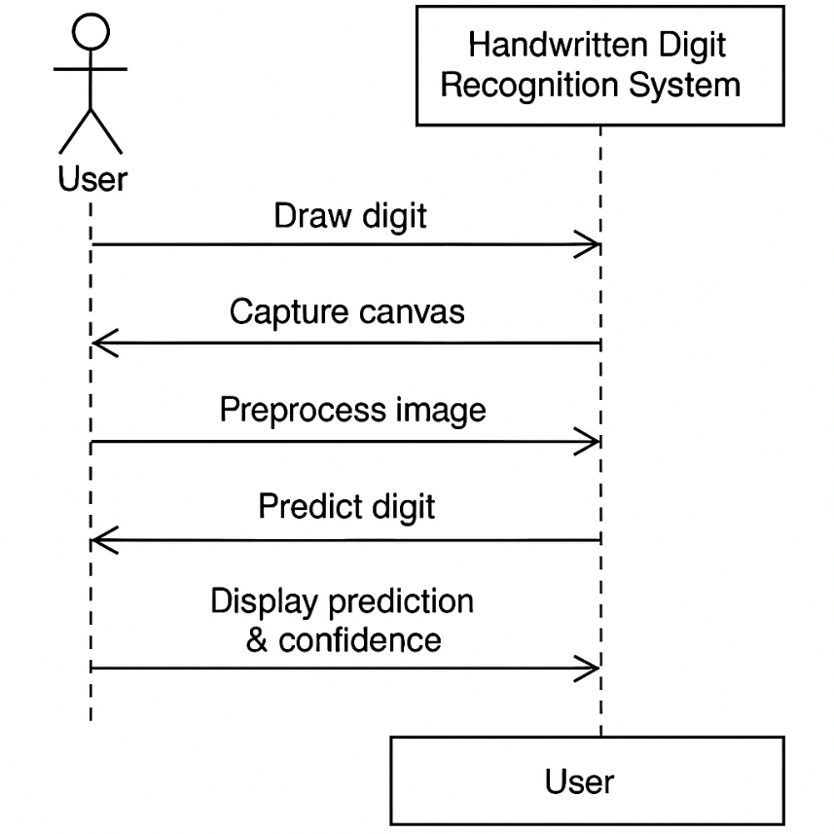

Fig 6.3 Sequence Diagram
.

CHAPTER 7

IMPLEMENTATION

Phase 1: Data Preparation (Short)
- Load digit images (0–9) from EMNIST/MNIST.
- Normalize pixel values to 0–1 and reshape to 28×28×1.
- Fix EMNIST orientation using rotate + flip.
- Split dataset into train/validation/test.
- Optionally apply light augmentation (shift/rotate/zoom).

Phase 2: Model Development (Short)
- Build a CNN: Conv → ReLU → MaxPool → Conv → ReLU → Flatten → Dense → Softmax(10).
- Compile using Adam optimizer + sparse categorical crossentropy.
- Train the model for 15–25 epochs with validation.
- Save the trained model and label map (0–9).

Phase 3: Deployment & Testing (Short)
- Create a Tkinter GUI with a drawing canvas.
- Capture the drawn image, preprocess exactly like training, and run model.predict().
- Display predicted digit + confidence.
- Save debugging images (last_capture.png) for testing correctness.

CHAPTER 8

RESULTS AND DISCUSSION

The handwritten digit recognition system was successfully trained using the EMNIST/MNIST dataset, achieving strong performance in classifying digits (0–9). During training, the model demonstrated steady improvement in both accuracy and loss, indicating effective learning of digit patterns such as curves, edges, loops, and line structures.
Validation accuracy remained close to training accuracy, showing that the model generalized well to unseen data and did not overfit significantly. The use of normalization, noise reduction, and orientation correction contributed to stable performance on test images.
When integrated with the Tkinter GUI, the model was able to interpret users’ handwritten digits drawn on the canvas. Preprocessing—such as inversion, centering, cropping, and resizing—played a crucial role in maintaining prediction reliability. Misclassifications occurred primarily when digits were written too small, too close to edges, or with unusual shapes that deviated significantly from training samples.
Overall, the system demonstrated that CNN-based digit recognition can operate effectively in real-time applications with minimal computational cost.

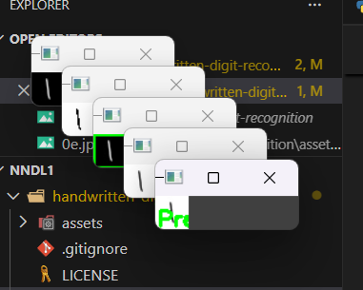

CHAPTER 9

CONCLUSION

This project successfully implemented a complete handwritten digit recognition system capable of identifying user-drawn digits through a trained convolutional neural network. The pipeline—from dataset preparation and model training to GUI-based real-time prediction—demonstrated the effectiveness of deep learning for image classification tasks.
The results confirm that CNNs can accurately learn and recognize handwritten digits when supported by proper preprocessing and balanced training data. The user interface provides an interactive and intuitive platform, making the system suitable for educational tools, digit-based input systems, and prototype handwriting applications.

CHAPTER 10

REFERENCES

• Cohen, G., Afshar, S., Tapson, J., & van Schaik, A. (2017). EMNIST: Extending MNIST to handwritten letters. IEEE International Joint Conference on Neural Networks (IJCNN), 2921–2926.
https://doi.org/10.1109/IJCNN.2017.7966217
• LeCun, Y., Bottou, L., Bengio, Y., & Haffner, P. (1998). Gradient-based learning applied to document recognition. Proceedings of the IEEE, 86(11), 2278–2324.
(Original MNIST paper)
• Goodfellow, I., Bengio, Y., & Courville, A. (2016). Deep Learning. MIT Press.
(CNN fundamentals used in digit recognition)

